CSC 352 / 452: Database Programming
assignment #4 (60 Points)

CSC 352/452-801:
- Due on Thursday, 10/4/2012 at midnight. Any homework that is late will lose 50% of the points for each day that it is late. No homework will be accepted more than two days after its due date.

CSC 352/452-810:
- Due on Friday, 10/5/2012 at midnight. Late homework will not be accepted or graded.

You do not need to use the REF cursors and Oracle collections in this assignment.

You are not allowed to create temporary tables/views/procedures/functions.

The EXCEPTION Section is NOT allowed in your program.

Hard coding (e.g., if child_name = 'Chicago' then ...) is not allowed in your program.

If you modified the tables created in Assignment #1, you need to truncate/delete and re-populate them.
1a) (CSC 352 only - 25 points)
Based on the tables created in Assignment #1, write a PL/SQL anonymous block to find all departments that have more than two employees whose salary is above 85% of the average salary of their respective departments. Sort your output by the department name.
Hard coding department names (EXECUTIVE, IT, RESEARCH) will get a zero point.

The output of your program must match the following:

DEPARTMENT NAME NUMBER OF EMPLOYEES
------------------------------------
EXECUTIVE 3
IT 3
RESEARCH 3

1b) (CSC 452 only – 20 points)
Based on the tables created in Assignment #1, write a PL/SQL anonymous block to find all departments that have more than two employees whose salary is above 85% of the average salary of their respective departments. Display the department names, the number of employees, and the corresponding employee names. Make sure that employees from the same department must be in the same line and separated by commas (e.g., IT <ADAMS, SCOTT, SMITH>). You will lose 5 points if you fail to do so. Sort your output by the department name and employee name.

Hard coding department names (EXECUTIVE, IT, RESEARCH) will get a zero point.

Hint: You may use your local variable v_output to display your output (e.g., v_output := v_output || '…'; DBMS_OUTPUT.PUT_LINE(v_output)).

The output of your program must match the following:

DEPARTMENT NAME NUMBER OF EMPLOYEES EMPLOYEE NAME
----------------------------------------------------------------
EXECUTIVE 3 <CLARK, JOST, KING>
IT 3 <ADAMS, SCOTT, SMITH>
RESEARCH 3 <LEE, WILSON, WOLFE>

2) (CSC 352 – 35 points | CSC 452 - 30 points)
The table REGIONS contains some regions of the world.

CREATE TABLE regions
(
PARENT_NAME VARCHAR2(30),
CHILD_NAME VARCHAR2(30)
);

INSERT INTO regions VALUES(NULL,'Asia');
INSERT INTO regions VALUES(NULL,'Australia');
INSERT INTO regions VALUES(NULL,'Europe');
INSERT INTO regions VALUES(NULL,'North America');
INSERT INTO regions VALUES('Asia','China');
INSERT INTO regions VALUES('Asia','Japan');
INSERT INTO regions VALUES('Australia','New South Wales');
INSERT INTO regions VALUES('New South Wales','Sydney');
INSERT INTO regions VALUES('Canada','Ontario');
INSERT INTO regions VALUES('China','Beijing');
INSERT INTO regions VALUES('England','London');
INSERT INTO regions VALUES('Europe','United Kingdom');
INSERT INTO regions VALUES('Illinois','Aurora');
INSERT INTO regions VALUES('Illinois','Chicago');
INSERT INTO regions VALUES('Illinois','Rockford');
INSERT INTO regions VALUES('Wisconsin','Madison');
INSERT INTO regions VALUES('Japan','Osaka');
INSERT INTO regions VALUES('Japan','Tokyo');
INSERT INTO regions VALUES('North America','Canada');
INSERT INTO regions VALUES('North America','United States');
INSERT INTO regions VALUES('Ontario','Ottawa');
INSERT INTO regions VALUES('Ontario','Toronto');
INSERT INTO regions VALUES('United States','Colorado');
INSERT INTO regions VALUES('United States','Illinois');
INSERT INTO regions VALUES('United States','Texas');
INSERT INTO regions VALUES('United Kingdom','England');
COMMIT;

Based on the REGIONS table, write a PL/SQL anonymous block that accepts a region name (CHILD_NAME) from the user input and display all its parent regions.

Hints:

- Check whether the region name that the user entered is in the CHILD_NAME column
of the REGIONS table.
- Check whether the region name that the user entered has a parent.
- Define a cursor to find the parent for a given child.
- Find all the parents by referencing your cursor repeatedly.
- Use the UPPER function to compare two names.
6) You may use your local variable v_output to display your output (e.g., v_output
:= '…' || v_output; DBMS_OUTPUT.PUT_LINE(v_output)).

Test your program to ensure that you get the correct results.

The output of your program must match mine EXACTLY. If your output does not match mine EXACTLY (e.g., your output does not have “----- End_Outout -----“.), you will lose some points.

Case 1)

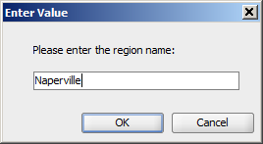

Output:

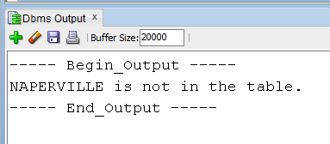

Case 2)

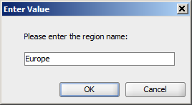

Output:

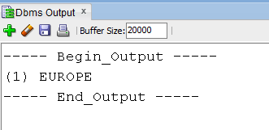

Case 3)

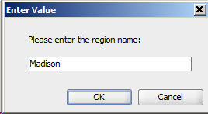

Output:

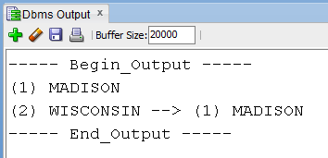

Case 4)

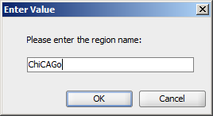

Output:

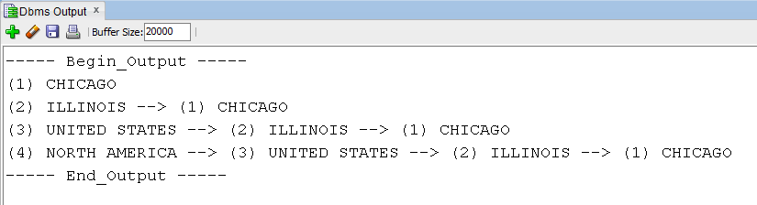

3) (CSC 452 only – 10 points)

We may have duplicate city names in the CHILD_NAME column. Modify your program created in (3) such that all parent regions of the duplicate city names can be displayed.

a) Add two new rows into the REGIONS table as follows,

INSERT INTO regions VALUES('Texas','Rockford');
INSERT INTO regions VALUES('Colorado','Aurora');
COMMIT;

b) Write a PL/SQL anonymous block that accepts a region name from the user input and display all its parent regions.

c) Test your program to ensure that you get the correct results.

The output of your program must match mine EXACTLY. If your output does not match mine EXACTLY (e.g., your output does not have “----- End_Outout -----“.), you will lose some points.

Case 1) User input: Naperville
Case 2) User input: Europe
Case 3) User input: Madison
Case 4) User input: Chicago
Case 5) User input: Aurora
Case 6) User input: Rockford

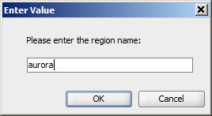

Output:

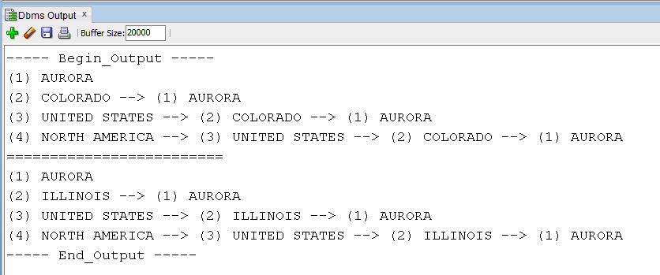

Case 6) User input: Rockford

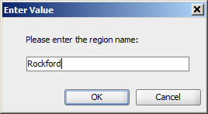

Output:

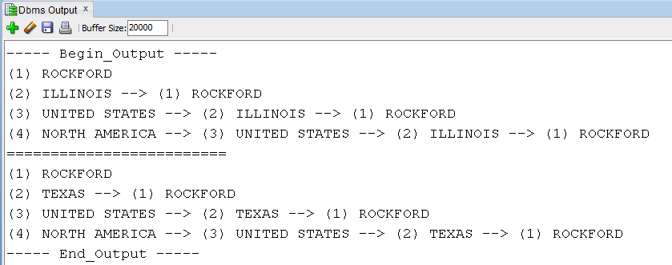

Please submit a text file containing all the source codes to COL before or on due date.

